Software Requirements And Specification

For

Traffic Monitoring System

Version 1.0 approved

Prepared by

Shish Been Baha Uddin(150225)

Md Imran Hussain(150240)

Computer Science & Engineering Discipline

Khulna University.

01.08.2018

Table of Contents

Table of Contents ii

Revision History ii

1. Introduction 1

1.1 Purpose 1

1.2 Document Conventions 2

1.3 Intended Audience and Reading Suggestions 2

1.4 Product Scope 2

1.5 References 2

2. Overall Description 2

2.1 Product Perspective 2

2.2 Product Functions 3

2.3 User Classes and Characteristics 3

2.4 Operating Environment 3

2.5 Design and Implementation Constraints 4

2.6 User Documentation 4

2.7 Assumptions and Dependencies 4

3. External Interface Requirements 4

3.1 User Interfaces 4

3.2 Hardware Interfaces 4

3.3 Software Interfaces 4

3.4 Communications Interfaces 4

4. System Features Error! Bookmark not defined.

4.1 System Feature 1 6

4.2 System Feature 2 (and so on) 6

5. Other Nonfunctional Requirements 7

5.1 Performance Requirements **Error! Bookmark not defined.**

5.2 Safety Requirements 7

5.3 Security Requirements 8

5.4 Software Quality Attributes 8

5.5 Business Rules **Error! Bookmark not defined.**

6. Other Requirements……………..Not Applied……………………………………………...

Appendix A: Glossary…………………..Not Applied…………………………………………...

Appendix B: Analysis Models……………Not Applied…………………………………………

Appendix C: To Be Determined List Error! Bookmark not defined.

Revision History

|  |  |  |  |
| --- | --- | --- | --- |
| **Name** | **Date** | **Reason For Changes** | **Version** |
|  |  |  |  |
|  |  |  |  |

# Introduction

City transportation is an important pillar for quality of life of citizens in a city. Currently, in most of the cities, public and private road transportation are the key mode of commuting and logistics. Some large and mega cities have metro and local train network as the backbone transportation mode. Lack of quality and safe public traffic system, inadequate capacity of public transportation, road safety concerns, overcrowded road network, poor traffic management, parking issues, theft, poor road conditions, lack of modal options remain the key issues in most of the cities. Most cities also lack the integrated traffic management plans leading to huge demand-supply gap and poor transportation network. For transport operators, huge demand-supply gap, under recovery and poor asset management remain the key issues.

## Purpose

Technology plays an important role by predicting demand and supply data to feed into transportation planning. Technology can also help in improving reliability of traffic system by providing visibility on arrivals/departures/route information for traveller’s for hassle-free journey. We will describe an Intelligent traffic management which can aid efficient traffic flow.

## Document Conventions

In this Document we will use the following conventions.

|  |  |
| --- | --- |
| DB | Database |
| ER | Entity Relationship |
| TMS | Transport monitoring system |

## 

## Intended Audience and Reading Suggestions

The document is mainly intended for Ordinary people and traveller’s. The document is included overall description of the system and their functionalities, user classes, product functions, operating environment, design, external interface and requirements, implementation, system features.

## Product Scope

Our traffic management solutions support the effective movement of people, tracking of goods, fleet management and everything else that keep a smart city on the go—such as facilitating vehicle-to-vehicle (V2V) communication, traffic monitoring, locating available parking, Smart traffic lights, Smart toll leverages technology and electric vehicle charging.

## References

[1] IEEE Software Engineering Standards Committee, “IEEE Std 830-1998, IEEE Recommended Practice for Software Requirements Specifications”, October 20, 1998.

[2]<https://www.tutorialspoint.com/software_testing_dictionary/software_requirement_specification.htm>l

# Overall Description

This section will give an overview of the whole system. The system will be explained in its context to show how the system interacts with other systems and introduce the basic functionality of it. It will also describe what type of peoples that will use the system and what functionality is available for each type. At last, the constraints and assumptions for the system will be presented.

## Product Perspective

TMS is a system which is similar to smart transportation. Though we use a lot of modern technologies in our day to day life ,but our transportation system is still analog. . Lack of quality and safe public transportation, inadequate capacity of public transportation, road safety concerns, overcrowded road network, poor traffic management, parking issues, theft, poor road conditions, lack of modal options remain the key issues in most of the cities. Main goals of TMS system is to find out all those difficulties in transportation and reduce them to make our life easier.

## Product Functions

The major features of database system as shown below

* Manage all the Traffic
* Manage all the Routes
* Manage all the Length
* Manage all the Traffic Police
* Manage all the Diversion
* Manage all the Vehicle Type.
* Give real time accident and traffic jam information.
* Find out places where new roads, bridge should be built.
* Find out jamprone areas and time of jam in particular areas,alternate roads .

## User Classes and Characteristics

User of the system can search the status of the traffic on which user wants to travel. If there is accident , traffic jam or any kind of blockage the user can find alternative roads using the system. User can know the location about the nearest parking lot.

The citizens should be able to perform the following task :

* User can check the current status of traffic.
* User can search Length, view description of a selected Length
* User can find out alternative roads.
* User will be able to search and generate report of Traffic Polices, Routes

Admin Functions:

* Update the current status of Traffic.
* Admin can update Length and delete Length.
* Admin also can update Traffic Polices, Routes, Divertions, Traffic information

## Operating Environment

Operating environment for the airline management system is as listed below.

* distributed database
* server system
* Operating system: Windows.
* database: sql + database
* platform: JavaScript/PHP

## Design and Implementation Constraints

* SQL commands for queries/applications.
* Implement the database at least using a centralized database management system.

## User Documentation

As the system is not completed yet, so user documentation cannot be made.

## Assumptions and Dependencies

Let us assume that

* Sometimes real-time status of the traffic may not be updated.
* Database server errors may occur.

# External Interface Requirements

## User Interfaces

* Front-end: HTML, Css, JavaScript
* Back-end: SQL+ , Php

## Hardware Interfaces

* Windows 10
* A browser which supports CSS, HTML

## Software Interfaces

Following are the software used for the events finder system application

|  |  |
| --- | --- |
| Software used | Description |
| Operating system | We have chosen Windows operating system for its best support and user-friendliness |
| Database | To save the events details we have chosen SQL database. |
| .Net | To implement the project we have chosen .Net language for its more interactive support. |

## Communications Interfaces

The project will support all types of web browser.

## System Feature for Admin

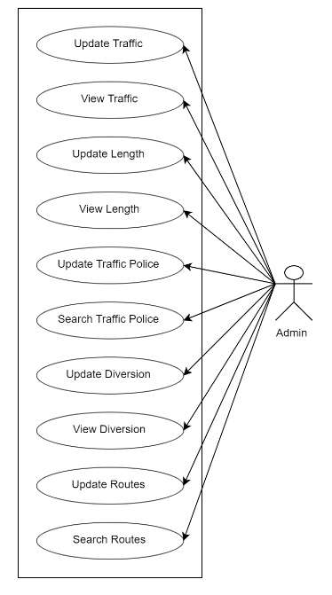

## System Feature for User

# Other Nonfunctional Requirements

## Performance Requirements

The basic objective of normalization is to reduce redundancy which means that information is to be stored only once. Storing information several times leads to wastage of storage space and increase in the total size of the data stored.

If a database is not properly designed it can give rise to modification anomalies. Modification anomalies arise when data is added to, changed or deleted from a database table. Similarly, in traditional databases as well as improperly designed relational databases, data redundancy can be a problem. These can be eliminated by normalizing a database.

## Safety Requirements

If there is extensive damage to a wide portion of the database due to a disk crash. Therefore,

admin should careful in this case.

## Security Requirements

Security systems need database storage just like many other applications. However, The

requirements of the security means that admin must choose their database partner carefully.

## Software Quality Attributes

* **AVAILABILITY:** The system should be available all the time for user.
* **CORRECTNESS:** The system should strict to its rules and regulation.
* **MAINTAINABILITY:** The administrators should update status of road in certain times.
* **USABILITY:** The system should satisfy a maximum number of users need.

**5.** **Use cases description**

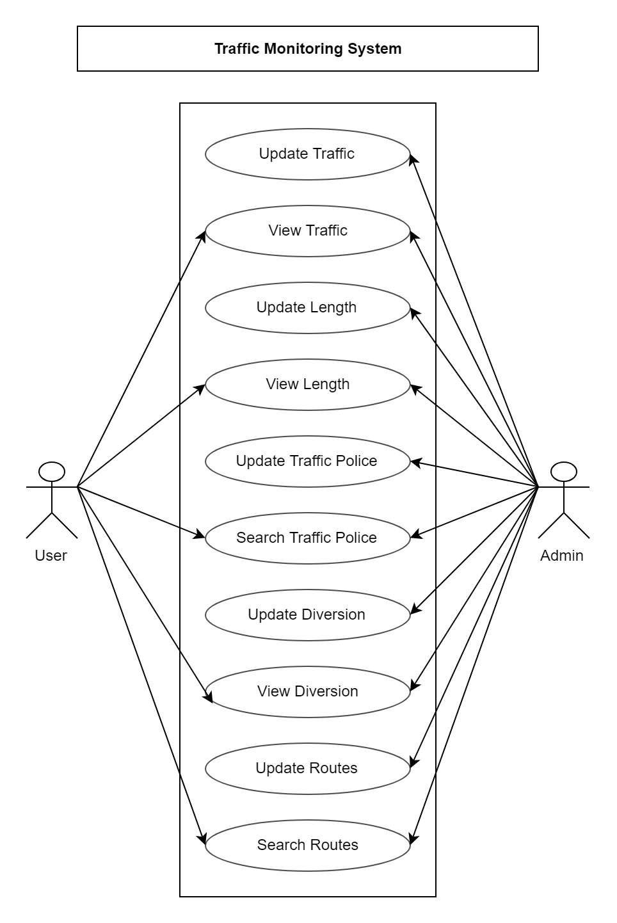

**5.1. Registration**

|  |  |
| --- | --- |
| **Use Case Name:** | Registration(Admin) |
| **Brief Description:** | Admin should be registered to access the system to manage all the operation on Traffic, length, Diversion Road, Traffic Police |
| **Priority** | Essential |
| **Trigger** | Admin fill the property |
| **Precondition** | User is connected to the internet and on the TMS home page. |
| **Basic Path** | Entered into the system & Click on the Register button. Fill up the text boxes named name, username, password, roll, address, date of birth and all the details. Click Submit. |
| **Alternate Path** | N/A |
| **Post condition** | User is on the registration form. |
| **Exception Path** | If there is a connection failure, the Server returns to the wait state. |

**5.2**. **Login into system**

|  |  |
| --- | --- |
| **Use Case Name:** | Login(Admin) |
| **Brief Description:** | To manage all the operation on Traffic, length, Diversion Road, Traffic Police ,Admin/user have to Login into the system |
| **Priority** | Essential |
| **Trigger** | To enter the system. |
| **Precondition** | User are connected to the internet and on the Home Page. |
| **Basic Path** | Entered into the system & Click on the login button. Fill up the text boxes named username, password. Click on login button |
| **Alternate Path** | N/A |
| **Post condition** | The survey record is created in the Survey Table of the Database. |
| **Exception Path** | If the connection is terminated before the form is submitted, the fields are all cleared and the Server is returned to the wait state. |

**5.3** **Seeing own details.**

|  |  |
| --- | --- |
| **Use Case Name:** | Seeing own details(Admin) |
| **Brief Description:** | This operation permits to see admin profile |
| **Priority** | Optional. |
| **Trigger** | View admin details. |
| **Precondition** | User are connected to the internet and on the View profile page. |
| **Basic Path** | Login into the system. Click on the view profile button & View own details. |
| **Alternate Path** | N/A |
| **Post condition** | User is on the View profile page. |
| **Exception Path** | If there is a connection failure, the Server returns to the wait state. |

**5.4** **Editing own details(Admin)**

|  |  |
| --- | --- |
| **Use Case Name:** | Editing own details(admin) |
| **Brief Description:** | This operation permits to update Admin details. |
| **Priority** | Optional. |
| **Trigger** | Update Admin profile. |
| **Precondition** | User are connected to the internet and on the Update profile page. |
| **Basic Path** | Login into the system. Select Profile from navigation Bar and click Edit. Enter the Admin/user details. Click the submit button. |
| **Alternate Path** | N/A |
| **Post condition** | User is on the update profile page and have admin roll. |
| **Exception Path** | 1. If the connection is terminated before the form is submitted, the fields are cleared and the Server is returned to the wait state. |

**5.5 Update Traffic details**

|  |  |
| --- | --- |
| **Use Case Name:** | Update Traffic details |
| **Brief Description:** | This operation permits admin to update Traffic details at a certain street. |
| **Priority** | Essential |
| **Trigger** | Admin update parkin spot in the TMS Database. |
| **Precondition** | Admin must be connected to the Internet, logged in and on the Traffic page |
| **Basic Path** | Login into the system. Select Traffic from navigation Bar and click Edit. Enter the Traffic details & click the update button. |
| **Alternate Path** | N/A |
| **Post condition** | User is on the traffic page and have admin roll. |
| **Exception Path** | 1. If the connection is terminated before the form is submitted, the fields are cleared and the Server is returned to the wait state. |

**5.6.** **Update Traffic Police details**

|  |  |
| --- | --- |
| **Use Case Name:** | Update Traffic Police Details |
| **Brief Description:** | This operation permits admin to update Traffic Police details. |
| **Priority** | Essential |
| **Trigger** | Admin modify traffic police details. |
| **Precondition** | Admin must be connected to the Internet, logged in and on the trafficPolice page |
| **Basic Path** | Login into the system. Select Traffic Police from navigation Bar and click Edit. Enter traffic police name, address, email, phone number and all the details. Click on the Update button. |
| **Alternate Path** | N/A |
| **Post condition** | User is on the Traffic Police and have admin roll. |
| **Exception Path** | 1. If the connection is terminated before the form is submitted, the fields are cleared and the Server is returned to the wait state. |

**5.7.** **Update Length**

|  |  |
| --- | --- |
| **Use Case Name:** | Update Length of the Traffic |
| **Brief Description:** | This operation permits Admin to update traffic length at a certain road to the TMS Database. |
| **Priority** | Essential |
| **Trigger** | Admin update Traffic length in the TMS Database. |
| **Precondition** | User is on the Length page and have admin roll. |
| **Basic Path** | Login into the system. Select Length from navigation Bar and click Edit. Enter the Traffic Length details & click the update button. |
| **Alternate Path** | N/A |
| **Post condition** | User is on the traffic Length page and have admin roll. |
| **Exception Path** | 1. If the connection is terminated before the form is submitted, the fields are cleared |

**5.8.** **Update traffic monitoring tool and requirement that will be improved**

|  |  |
| --- | --- |
| **Use Case Name:** | Update traffic monitoring tool and requirement that will be improved |
| **Brief Description:** | This operation permits the Admin/User to Update traffic monitoring tool and requirement that will be improved. |
| **Priority** | Essential. |
| **Trigger** | Admin update speed traffic monitoring tool in TMS database. |
| **Precondition** | User is on the Requirement page and have admin roll. |
| **Basic Path** | Login into the system. Click requirement button. Note the information about damaged roads, under-construction roads, broken bridges. Select where CCTV cameras is needed in such an important position. Note the place where street light is required. Click update button. |
| **Alternate Path** | N/A |
| **Post condition** | User is on the requirement page and have admin roll. |
| **Exception Path** | 1. If the connection is terminated before the information is returned, the Server is returned to the wait state. |

**5.9. Update Routes**

|  |  |
| --- | --- |
| **Use Case Name:** | Update Traffic Routes |
| **Brief Description:** | This operation permits the Admin to Update Traffic Routes in the city. |
| **Priority** | Essential. |
| **Trigger** | Admin update jam-prone areas list in TMS database. |
| **Precondition** | User is on the Routes page and have admin roll. |
| **Basic Path** | Login into the system. Select Routes from navigation Bar and click Edit. Enter the Routes details & click the update button. |
| **Alternate Path** | N/A |
| **Post condition** | User is on the jam-prone page and have admin roll. |
| **Exception Path** | 1. If the connection is terminated before the information is returned, the Server is returned to the wait state. |

**5.10. Update Diversion Routes**

|  |  |
| --- | --- |
| **Use Case Name:** | Update Diversion |
| **Brief Description:** | This operation permits the Admin to Update Diversion Routes in the city. |
| **Priority** | Essential. |
| **Trigger** | Admin update jam-prone areas list in TMS database. |
| **Precondition** | User is on the Routes page and have admin roll. |
| **Basic Path** | Login into the system. Select Diversion from navigation Bar and click Edit. Enter the Routes details & click the update button. |
| **Alternate Path** | N/A |
| **Post condition** | User is on the jam-prone page and have admin roll. |
| **Exception Path** | 1. If the connection is terminated before the information is returned, the Server is returned to the wait state. |

**5.11. View Traffic details**

|  |  |
| --- | --- |
| **Use Case Name:** | View Traffic details |
| **Brief Description:** | This operation permits admin or user to search Traffic details, View description of the traffic. |
| **Priority** | Essential |
| **Trigger** | Admin/user search traffic in the TMS Database. |
| **Precondition** | Admin must be connected to the Internet, logged in and on the Traffic page |
| **Basic Path** | Login into the system. Select Traffic from navigation Bar and click View. That will show all the traffic details. |
| **Alternate Path** | N/A |
| **Post condition** | User is on the traffic page and have user roll |
| **Exception Path** | 1. If the connection is terminated before the form is submitted, the fields are cleared and the Server is returned to the wait state. |

**5.12. View Routes details**

|  |  |
| --- | --- |
| **Use Case Name:** | View Routes details |
| **Brief Description:** | This operation permits admin or user to search Routes details, View description of routes. |
| **Priority** | Essential |
| **Trigger** | Admin/user search traffic routes in the TMS Database. |
| **Precondition** | Admin must be connected to the Internet, logged in and on the Routes page |
| **Basic Path** | Login into the system. Select Routes from navigation Bar and click View. That will show all the Routes details. |
| **Alternate Path** | N/A |
| **Post condition** | User is on the routes page and have user roll |
| **Exception Path** | 1. If the connection is terminated before the form is submitted, the fields are cleared and the Server is returned to the wait state. |

**5.13. View Diversion Routes details**

|  |  |
| --- | --- |
| **Use Case Name:** | View Diversion Routes details |
| **Brief Description:** | This operation permits admin or user to search Diversion Routes details, View description of Diversion routes. |
| **Priority** | Essential |
| **Trigger** | Admin/user search Diversion routes in the TMS Database. |
| **Precondition** | Admin must be connected to the Internet, logged in and on the Diversion page |
| **Basic Path** | Login into the system. Select Diversion from navigation Bar and click View. That will show all the Diversion Routes details. |
| **Alternate Path** | N/A |
| **Post condition** | User is on the routes page and have user roll |
| **Exception Path** | 1. If the connection is terminated before the form is submitted, the fields are cleared and the Server is returned to the wait state. |

**5.13. View Length of the traffic**

|  |  |
| --- | --- |
| **Use Case Name:** | View Length of the Traffic |
| **Brief Description:** | This operation permits admin or user to search Diversion Length of the Traffic and View description. |
| **Priority** | Essential |
| **Trigger** | Admin/user search Length in the TMS Database. |
| **Precondition** | Admin must be connected to the Internet, logged in and on the Length page |
| **Basic Path** | Login into the system. Select Length from navigation Bar and click View. That will show all the Traffic Length details. |
| **Alternate Path** | N/A |
| **Post condition** | User is on the routes page and have user roll |
| **Exception Path** | 1. If the connection is terminated before the form is submitted, the fields are cleared and the Server is returned to the wait state. |

**Detailed Design OF Traffic Monitoring System**

**6. Traffic Monitoring System Activity Diagram:**

This is the Activity UML diagram of Traffic Monitoring System which shows the flows between the activity of Length, Traffic, Divertions, Traffic Polices, Routes. The main activity involved in this <strong>UML Activity Diagram of Traffic Monitoring System are as follows:

* Length Activity
* Traffic Activity
* Divertions Activity
* Traffic Polices Activity
* Routes Activity

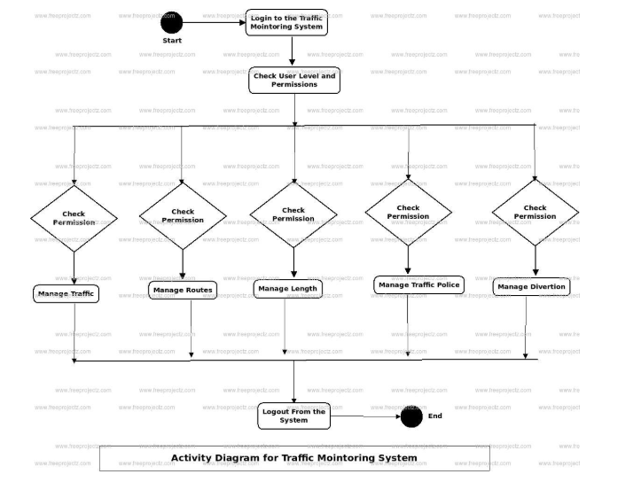

**6.1 Traffic Monitoring Class Diagram:**

Traffic Monitoring System Class Diagram describes the structure of a Traffic Monitoring System classes, their attributes, operations (or methods), and the relationships among objects. The main classes of the Traffic Monitoring System are Traffic, Routes, Length, Traffic Polices, Divertions, Vehicle Types.

Classes of Traffic Monitoring System Class Diagram:

* **Traffic Class**: Manage all the operations of Traffic.
* **Routes Class:** Manage all the operations of Routes
* **Length Class:** Manage all the operations of Length.
* **Traffic Polices Class:** Manage all the operations of Traffic Polices.
* **Divertions Class:** Manage all the operations of Divertions.
* **Vehicle Types Class**: Manage all the operations of Vehicle Types.

Classes and their attributes of Traffic Monitoring System Class Diagram:

* **Traffic Attributes**: traffic_id, traffic_name, traffic_type, traffic_description.
* **Routes Attributes**: route_id, route_name, route_type, route_description.
* **Length Attributes:** length_id, length_name, length_type, length_description.
* **Traffic Polices Attributes:** traffic_police_id, traffic_police_college_id, traffic_police_name, traffic_police_mobile, traffic_police_email, traffic_police_username, traffic_police_password, traffic_police_address.
* **Divertions Attributes:** divertion_id, divertion_name, divertion_type, divertion_description.
* **Vehicle Types Attributes:** vehicle_type_id, vehicle_type_customer_id, vehicle_type_number, vehicle_type_description

Classes and their methods of Traffic Monitoring System Class Diagram:

* **Traffic Methods**: addTraffic(), editTraffic(), deleteTraffic(), updateTraffic(), saveTraffic(), searchTraffic()
* **Routes Methods**: addRoutes(), editRoutes(), deleteRoutes(), updateRoutes(), saveRoutes(), searchRoutes()
* **Length Methods**: addLength(), editLength(), deleteLength(), updateLength(), saveLength(), searchLength()
* **Traffic Polices Methods**: addTraffic Polices(), editTraffic Polices(), deleteTraffic Polices(), updateTraffic Polices(), saveTraffic Polices(), searchTraffic Polices()
* **Divertions Methods:** addDivertions(), editDivertions(), deleteDivertions(), updateDivertions(), saveDivertions(), searchDivertions()
* **Vehicle Types Methods:** addVehicle Types(), editVehicle Types(), deleteVehicle Types(), updateVehicle Types(), saveVehicle Types(), searchVehicle Types()

Class Diagram of Traffic Monitoring System :

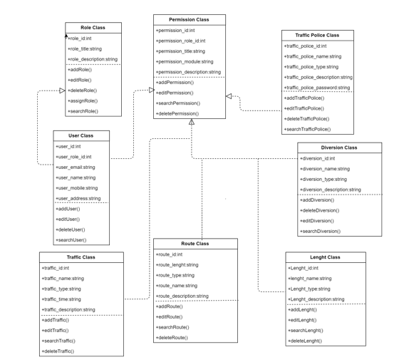

**6.2 Traffic Monitoring System Dataflow Diagram:**

Traffic Monitoring System Data flow diagram is often used as a preliminary step to create an overview of the Traffic without going into great detail, which can later be elaborated.it normally consists of overall application dataflow and processes of the Traffic process. It contains all of the userflow and their entities such all the flow of Traffic, Routes, Length, Traffic Police, Diversions, Vehicle Type, Login. All of the below diagrams has been used for the visualization of data processing and structured design of the Traffic process and working flow.

**6.2.1 Zero Level Data flow Diagram(0 Level DFD) of Traffic Monitoring System :**

This is the Zero Level DFD of Traffic Monitoring System, where we have eloborated the high level process of Traffic. It’s a basic overview of the whole Traffic Monitoring System or process being analyzed or modeled. It’s designed to be an at-a-glance view of Diversions,Vehicle Type and Login showing the system as a single high-level process, with its relationship to external entities of Traffic,Routes and Length. It should be easily understood by a wide audience, including Traffic,Length and Diversions In zero leve DFD of Traffic Monitoring System, we have described the high level flow of the Traffic system.

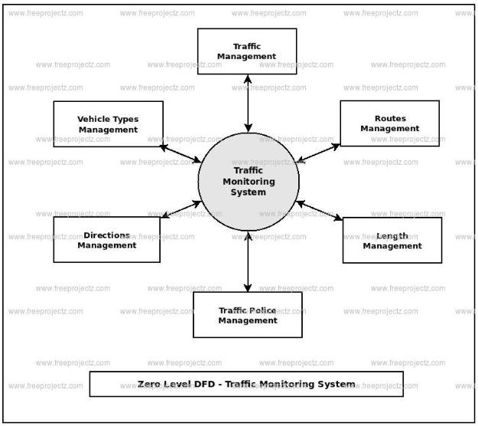

**6.2.2 First Level Data flow Diagram(1st Level DFD) of Traffic Monitoring System :**

First Level DFD (1st Level) of Traffic Monitoring System shows how the system is divided into sub-systems (processes), each of which deals with one or more of the data flows to or from an external agent, and which together provide all of the functionality of the Traffic Monitoring System system as a whole. It also identifies internal data stores of Login, Vehicle Type, Diversions, Traffic Police, Length that must be present in order for the Traffic system to do its job, and shows the flow of data between the various parts of Traffic, Length, Vehicle Type, Login, Diversions of the system. DFD Level 1 provides a more detailed breakout of pieces of the 1st level DFD. You will highlight the main functionalities of Traffic.

Main entities and output of First Level DFD (1st Level DFD):

* Processing Traffic records and generate report of all Traffic
* Processing Routes records and generate report of all Routes
* Processing Length records and generate report of all Length
* Processing Traffic Police records and generate report of all Traffic Police
* Processing Diversions records and generate report of all Diversions
* Processing Vehicle Type records and generate report of all Vehicle Type
* Processing Login records and generate report of all Login

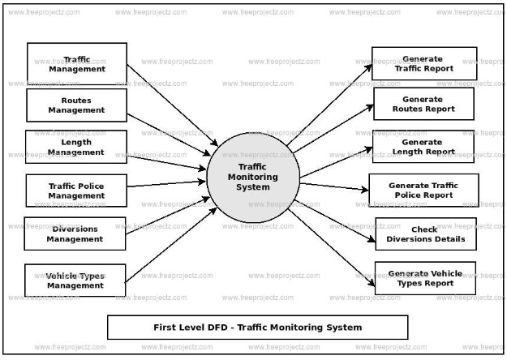

**6.2.3 Second Level Data flow Diagram(2nd Level DFD) of Traffic Monitoring System :**

DFD Level 2 then goes one step deeper into parts of Level 1 of Traffic. It may require more functionalities of Traffic to reach the necessary level of detail about the Traffic functioning. First Level DFD (1st Level) of Traffic Monitoring System shows how the system is divided into sub-systems (processes). The 2nd Level DFD contains more details of Login, Vehicle Type, Diversions, Traffic Police, Length, Routes, Traffic.

**Low level functionalities of Traffic Monitoring System**

* Admin logins to the system and manage all the functionalities of Traffic Monitoring System
* Admin can add, edit, delete and view the records of Traffic, Length, Diversions, Login.
* Admin can manage all the details of Routes, Traffic Police, Vehicle Type
* Admin can also generate reports of Traffic, Routes, Length, Traffic Police, Diversions, Vehicle Type
* Admin can search the details of Routes, Diversions, Vehicle Type
* Admin can search the details of Routes, Diversions, Vehicle Type
* Admin can tracks the detailed information of Routes, Length, Traffic Police, , Diversions

Second Level DFD -Traffic Monitoring System:

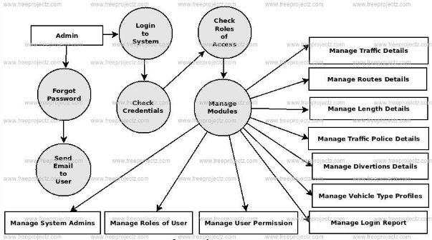

**6.3 Traffic Monitoring System ER Diagram:**

This ER (Entity Relationship) Diagram represents the model of Traffic Monitoring System Entity. The entity-relationship diagram of Traffic Monitoring System shows all the visual instrument of database tables and the relations between Routes, Traffic Polices, Traffic, Vehicle Types etc. It used structure data and to define the relationships between structured data groups of Traffic Monitoring System functionalities. The main entities of the Traffic Monitoring System are Traffic, Routes, Length, Traffic Polices, Divertions and Vehicle Types.

**Traffic Monitoring System entities and their attributes :**

* **Traffic Entity:** Attributes of Traffic are traffic_id, traffic_name, traffic_type, traffic_description
* **Routes Entity:** Attributes of Routes are route_id, route_name, route_type, route_description
* **Length Entity:** Attributes of Length are length_id, length_name, length_type, length_description
* **Traffic Polices Entity:** Attributes of Traffic Polices are traffic_police_id, traffic_police_college_id, traffic_police_name, traffic_police_mobile, traffic_police_email, traffic_police_username, traffic_police_password, traffic_police_address
* **Divertions Entity:** Attributes of Divertions are divertion_id, divertion_name, divertion_type, divertion_description
* **Vehicle Types Entity:** Attributes of Vehicle Types are vehicle_type_id, vehicle_type_customer_id, vehicle_type_number, vehicle_type_description

**ER Diagram For Traffic Monitoring System:**

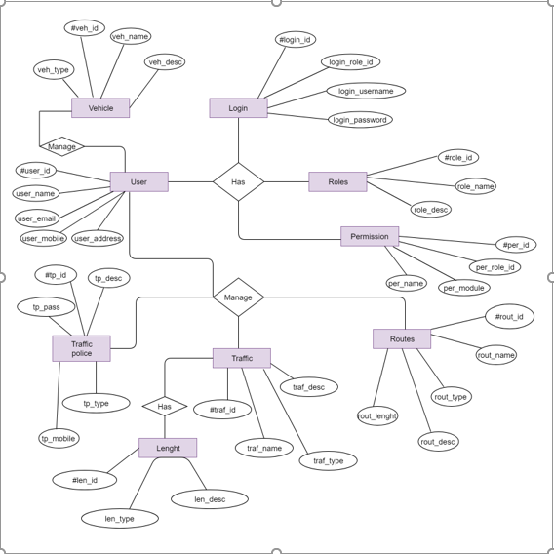

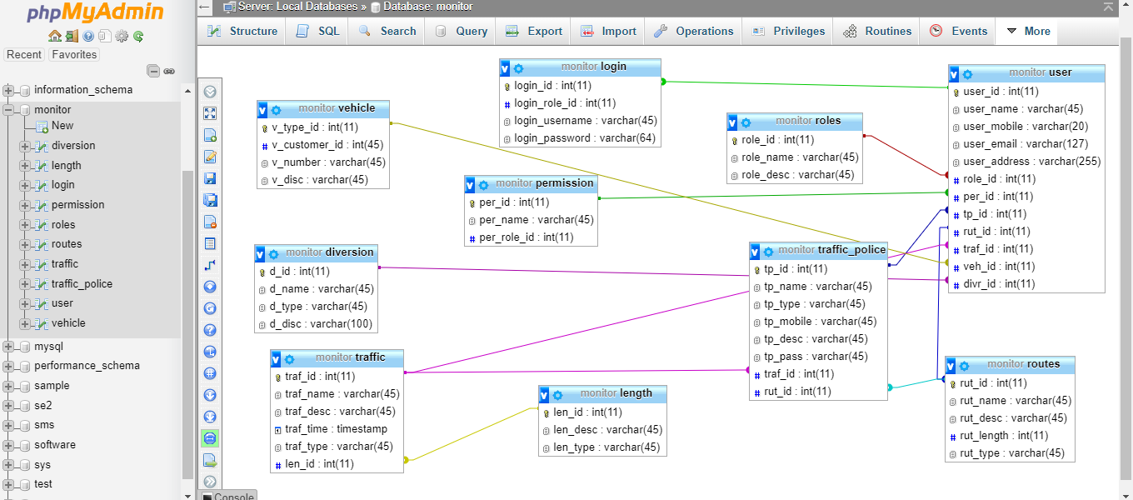**6.4 Schema diagram For Traffic Monitoring System:**

**6.5 UI Design**

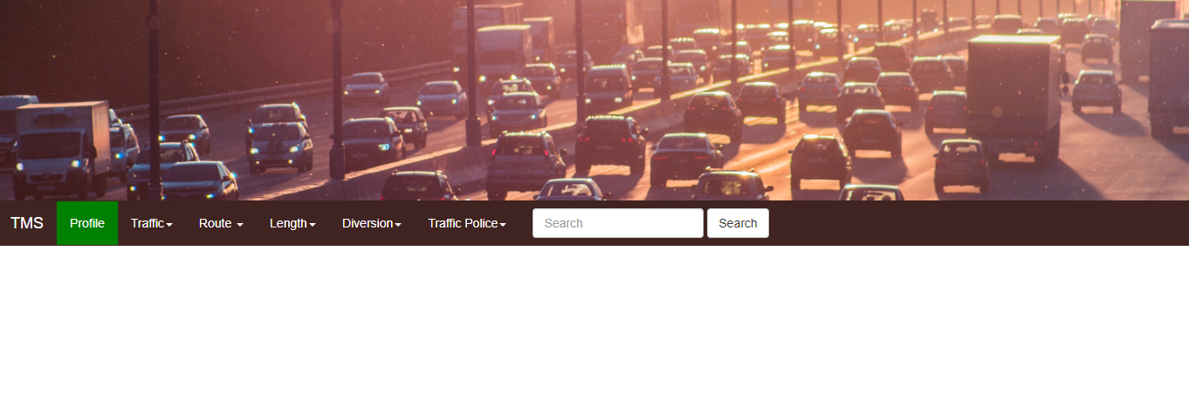

Home Page

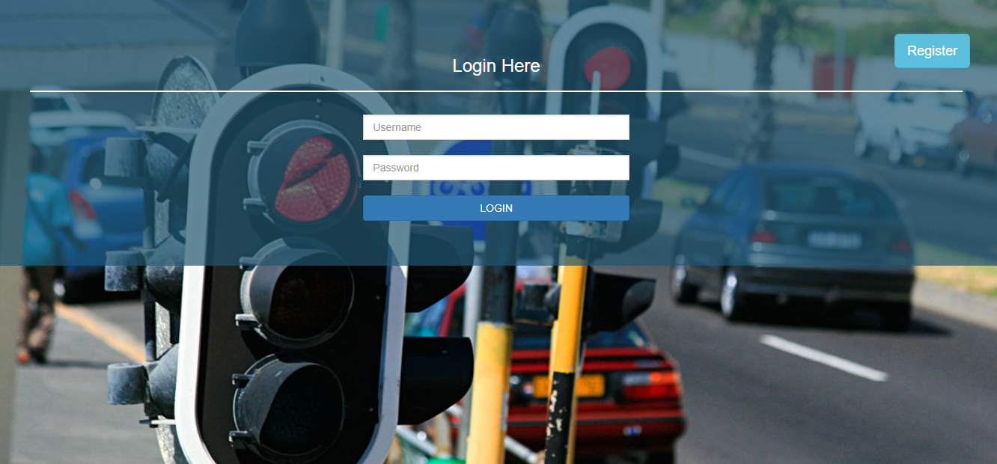

Login Page

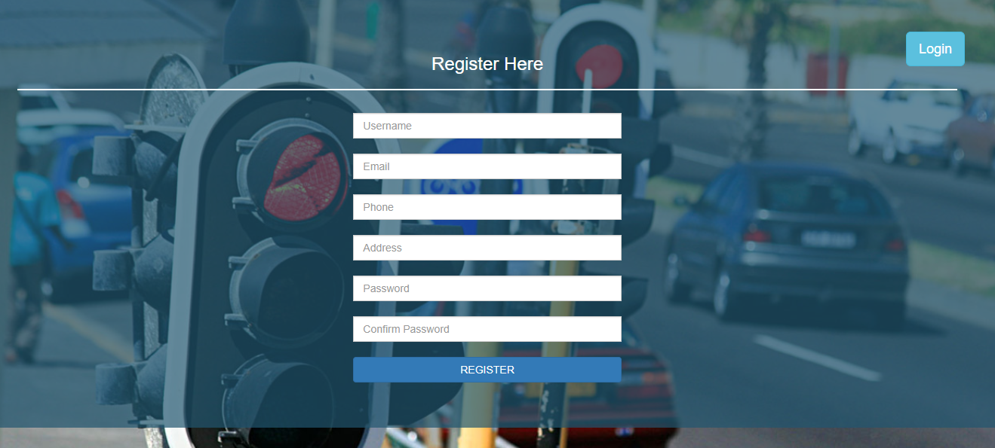

Registration Page

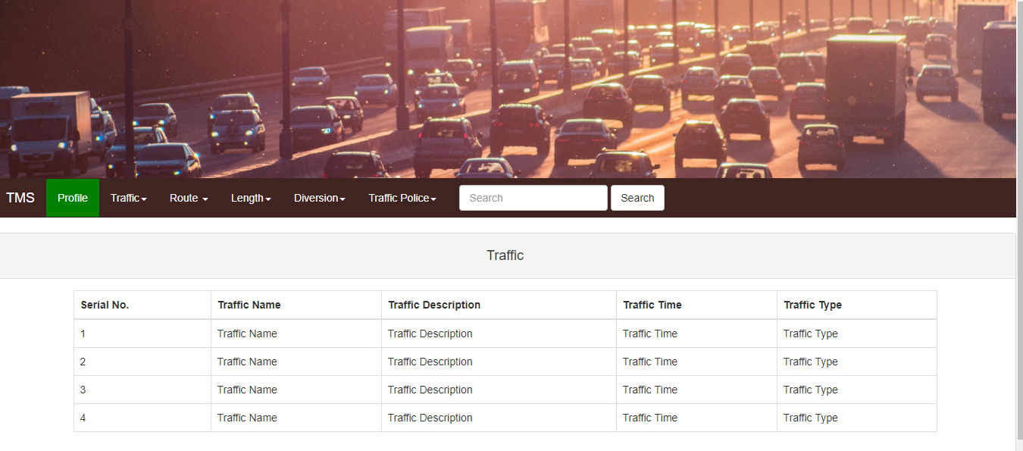

Traffic View Page

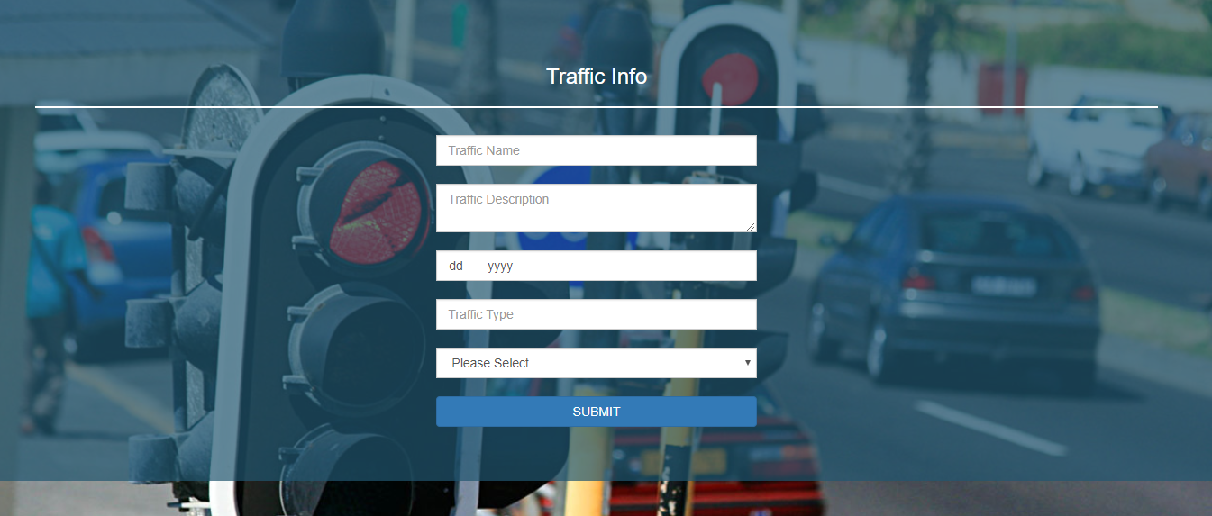

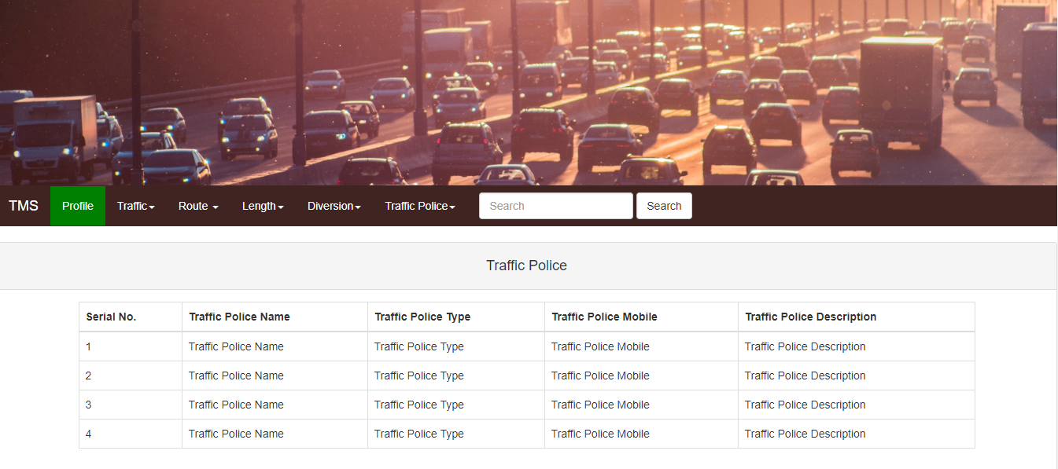 Traffic Edit Page

Traffic Police View page



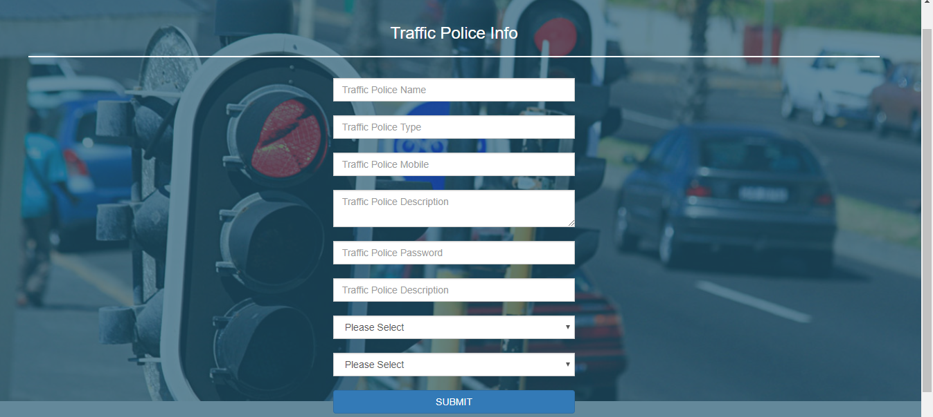

Traffic Police edit Page

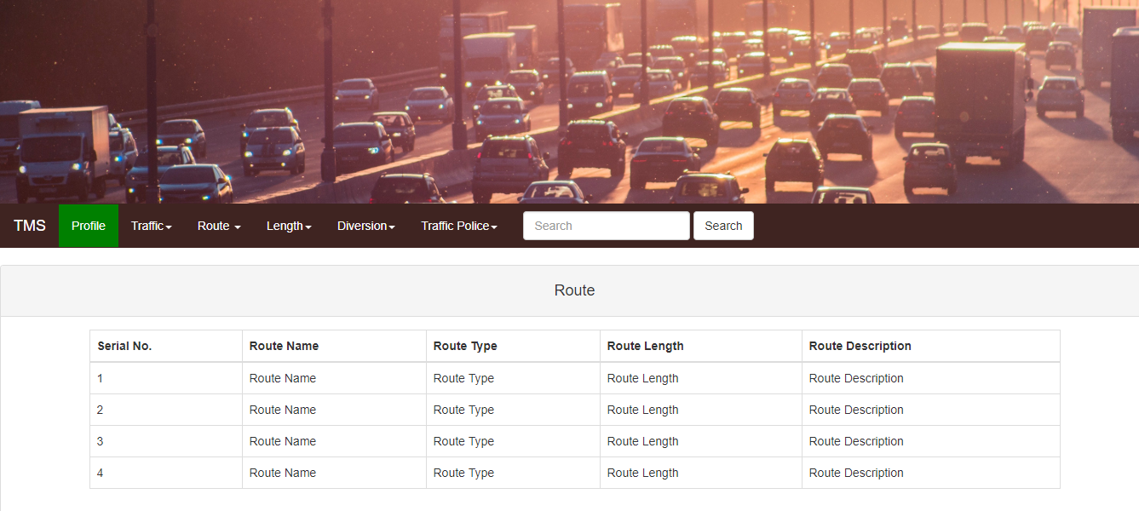

Traffic Route View Page

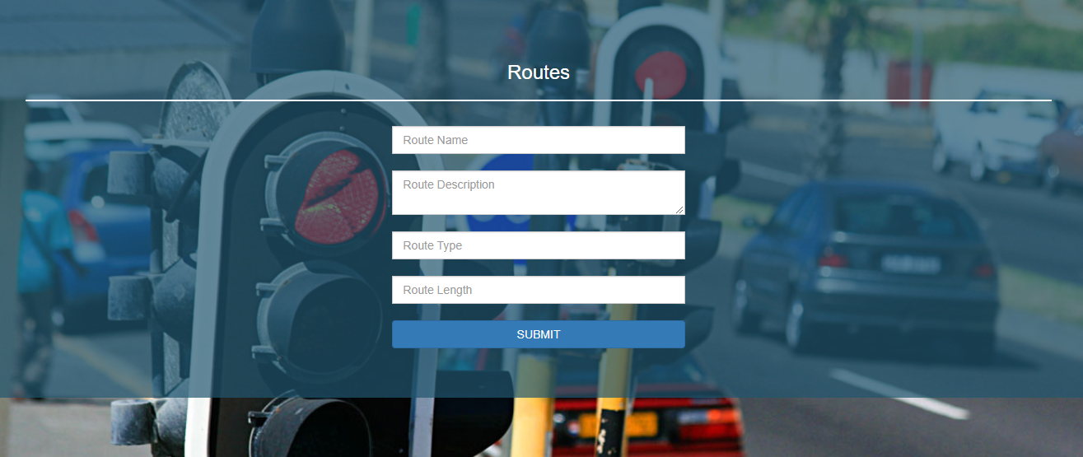

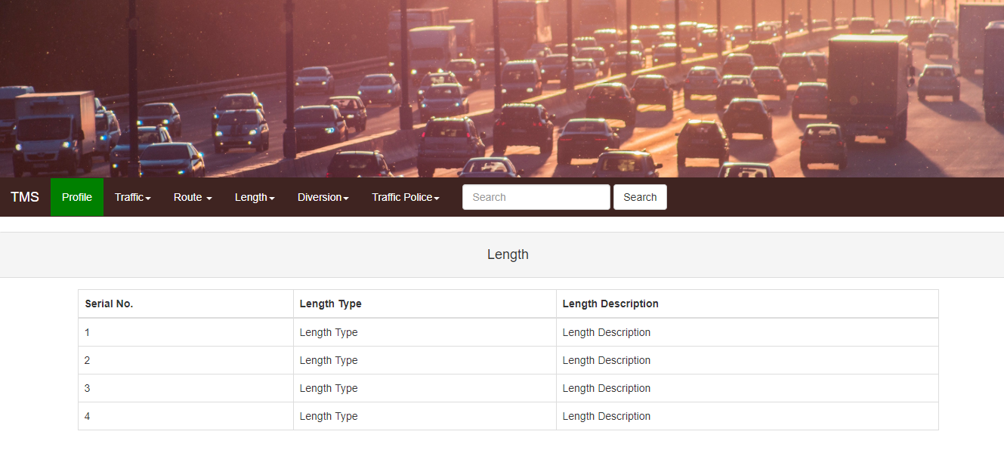 Traffic Route Edit Page

Traffic Length View Page

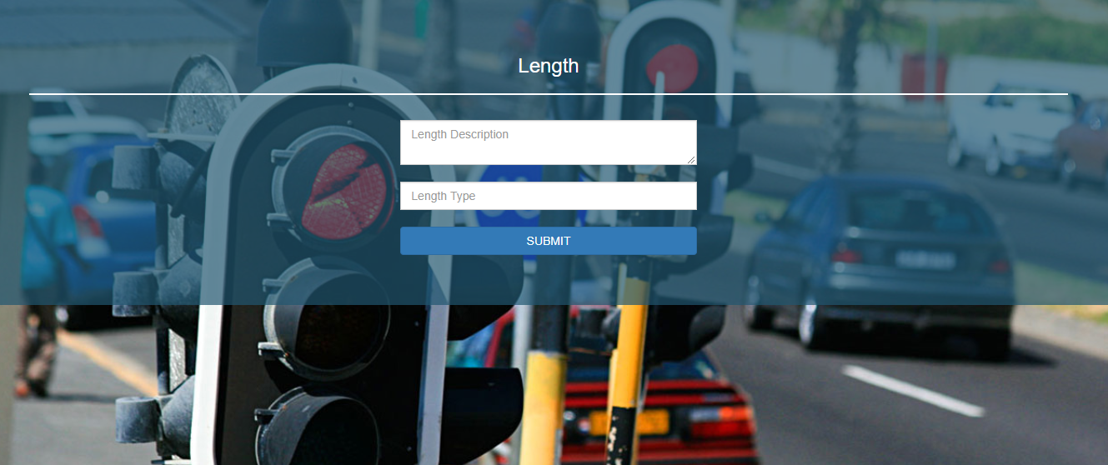

Traffic Length Edit Page

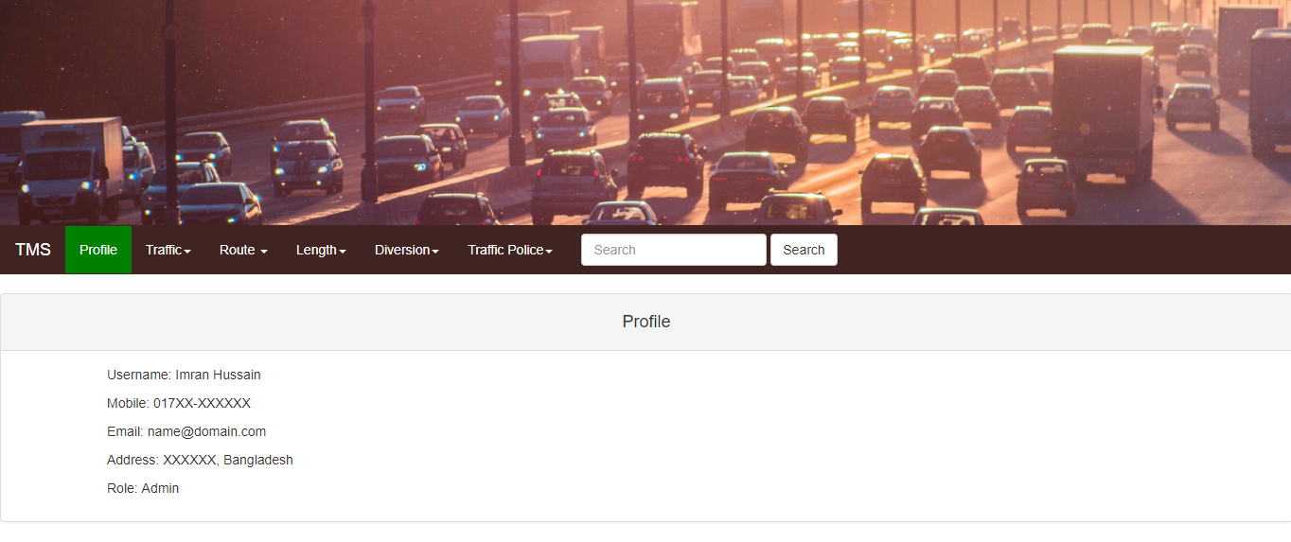

Profile View Page

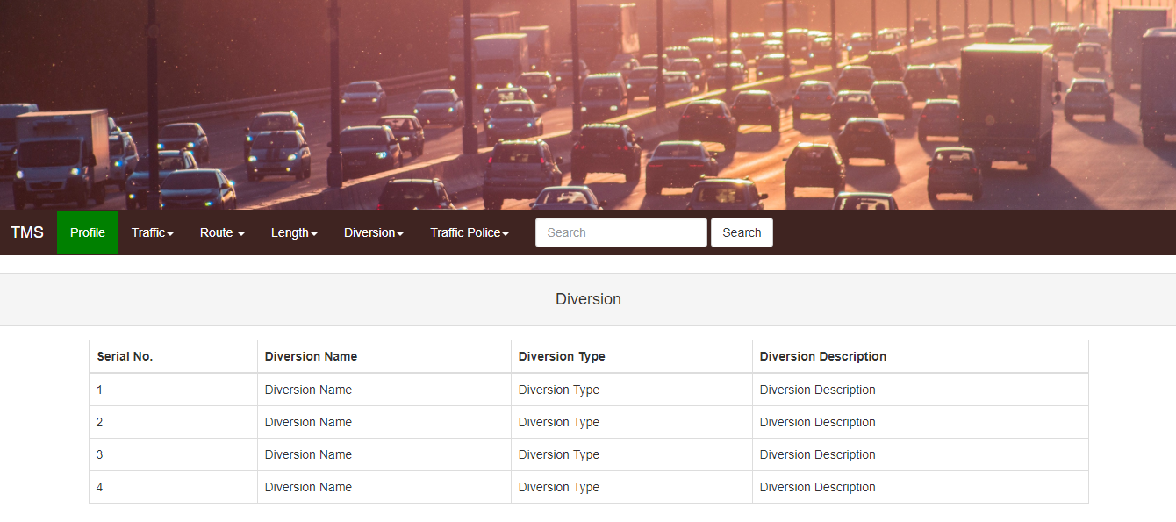Diversion Route View Page

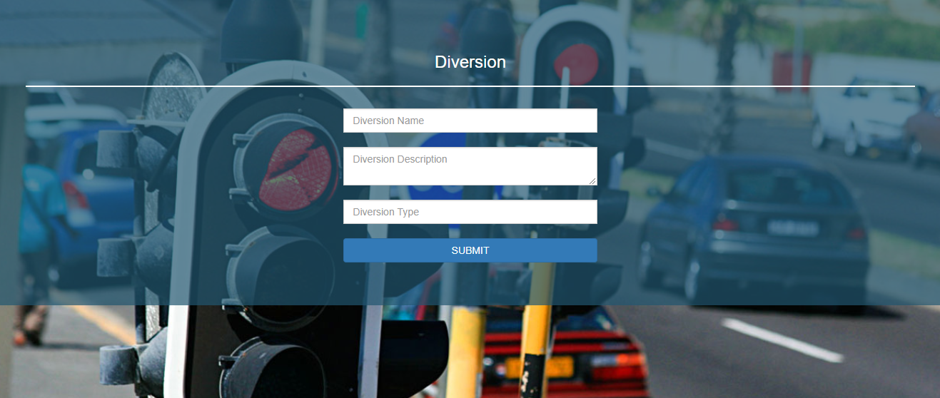

Diversion Route Edit Page